USAJOBS®
Guide to the USAJOBS Staffing Integration Framework

FROM:
Office of the Chief Information Officer
U.S. Office of Personnel Management
1900 E Street NW
Washington, DC

March 23, 2018

Version 3.0



The contents of this document are confidential and shall not be disclosed outside the Government and shall not be duplicated, used, or disclosed-in whole or in part-for any purpose other than that intended by the creator.

Revision Sheet

Version Number | Date | Revision Description
0.01 | 01/2011 | Initial draft guidance describing data interchanges for OPM’s USAJOBS.
0.02 | 02/17/2011 | Draft Guidance Describing the Staffing Integration Framework for USAJOBS 3.0
0.03 | 02/25/2011 | Draft Baseline Version for Vendor Review
0.04 | 3/10/11 | Draft with Edits – Vendor Feedback and Internal Review Findings
0.05 | 4/12/11 | Draft with Edits – Enumeration Validation
0.06 | 4/19/11 | Draft Final
0.07 | 7/5/11 | Draft Final with Edits
0.07a | 7/11/11 | Minor Corrections based on Testing (paragraphs 2.4, 3.1, 3.2 and 3.8)
1.0 | 7/21/11 | Final SIF Guide – Core Development Code Freeze – Pending VAT Findings
1.1 | 9/23/11 | Updates based on VAT Findings and Fixes
1.2 | 6/3/12 | Documentation and Process Clarifications
1.3 | 8/19/12 | Release 3.4 Modifications/Changes
1.4 | 12/2/12 | Release 3.5 Modifications/Changes
1.5 | 1/27/13 | Release 3.6 Modifications/Changes
1.6 | 10/27/13 | Release 4.0 Modifications/Changes
1.7 | 11/22/13 | Document Open API changes to retrieve locations and clarify the use of AgencyMarketingURL and BenefitsURL.
1.8 | 3/31/14 | Update Data Dictionary to “as-is” state after the 4.3 release and correct contacts and correct salary edit.
1.9 | 5/18/14 | Update SIF Guide and Data Dictionary to include disability codes and the application status override text as well as a correction to Required Documents.
2.0 | 2/3/14 | Update SIF Guide and Data dictionary to correct contacts and update Job Preview XSLT documentation.

Revision Detail Summary

Version Number | Reference | Description of Changes
1.0 | 2.5 | Updated all tables with final value sets. Changes incorporate changes mandated by GPDS Data Standard release 4, 5, and 6. Changes also reflect any changes needed to support migration. NOTE: Locations are now contained in two separate files. The 4 character DLC codes reflect the current code set with 3.0 changes to disable throughout codes and add critical replacement codes for international cities and countries. The 9 character duty station code is provided separately to make transition easier. In all cases, the 4 or 9 character codes are accepted.
1.0 | 4.1 | Candidate FormPost HR-XML example changed on Schema site to properly reflect FileType values in the CodeList enumeration file.
1.0 | 5.2 | ShowCandidate-DocumentAccept was modified to properly reflect the correct FileType value in the CodeList enumeration file.
1.0 | Section 7.1 | Updated to reflect final data changes.
1.0 | Section 7.9 | Updated to reflect new 2.0 Data Type Description
1.1 | Section 2.1.2 | Modified UAT URL for SIF Access
1.1 | Section 2.1.6 | Added clarifying language to the Authenticate Token requirements for Test and Production access. Also modified the process for requesting access to reflect updated procedures.
1.1 | Section 2.5 | Added Location Expansions URL.
1.1 | Section 2.6 | Updated to reflect production Batch Processing reference for SFTP.
1.1 | Section 2.8 | Updated to reflect modified procedures using Footprints.
1.1 | Section 7 | Added new section to describe the capabilities associated with JOA Export, RSS Feeds and Job Search Capabilities.
1.1 | Section 8 | Changed previous Section 7 to Section 8 and updated the Data Dictionary to correct minor documentation errors.
1.2 | Section 1.3 | Updated to reflect current operational state
1.2 | Section 2.1.1 | Updated to reflect current operational state
1.2 | Section 2.1.3 | Updated to reflect current operational state
1.2 | Section 2.1.6 | Updated to reflect current operational state
1.2 | Section 2.3 | Updated to reflect current operational state
1.2 | Section 2.7 | Updated to reflect current operational state
1.2 | Section 3.6 | Updated to reflect current operational state
1.2 | Section 3.7 | Updated to reflect current operational state
1.2 | Section 3.8 | Updated to reflect current operational state
1.2 | Section 4 | Updated to reflect current operational state and optional us of SessionTicket
1.2 | Section 4.1 | Updated to reflect current operational state and optional us of SessionTicket
1.2 | Section 4.2 | Updated to reflect current operational state and optional us of SessionTicket
1.2 | Section 4.3 | Updated to reflect current operational state and optional us of SessionTicket. Also added example to differentiate between ShowCandidate with Builder Resume versus Document Resume.
1.2 | Section 4.4 | Updated to reflect current operational state
1.2 | Table 4.1 | Added Optional attribute “SessionTicket”
1.2 | Figure 7.3 | Added Dynamic Search Attribute “Keyword” and modified query criteria for Country and CountrySubDivision
1.2 | Section 7.3 | Added Dynamic Search Attributes “LocationName”, “GradeLow”, “GradeHigh”, “Keyword” and modified query criteria for Country and CountrySubDivision
1.2 | Section 8.3 | Removed USAJOBS 2.0 Reference data from the Data Dictionary
1.3 | Section 1.4 | Removed reference to SORN OPM/GOVT-6 as it no longer applies.
1.3 | Table 2.2 | Modified to include ZipCode.XML Enumeration Reference Table
1.3 | Multiple Sections | All references to accessusajobs@opm.gov have been changed to access@usajobs.gov as the email address has been updated.
1.3 | 7.1.2 | Modified to include new alternate source tracking for JOA Export Consumers when GetJob/ViewDetails is used.
1.3 | 7.1.2.1 | Modified to include new alternate source tracking for JOA Export Consumers when GetJob/ViewDetails is used.
1.4 | 1.5 | Contact information updated to reflect organizational changes.
1.4 | 7.3.3 | A new parameter of Student was added and the documentation for the SES parameter was corrected.
1.5 | 1.5 | Contact Information was updated.
1.5 | 3.10 | Section 3.10 added to discuss the JOA Preview XSLT and its use.
1.5 | 7.1.2 | JOA Export was modified to include an explanation of embedded HTML and future dated JOAs.
1.6 | 8.2.2 | New JOA fields and edits.
1.6 | 3.10 | JOA Preview XSLT changes.
1.6 | 8.2.2 | New JOA fields and edits.
1.6 | 8.2.3 | New Candidate fields and edits.
1.6 | 2.7 | Reference SSO Information and Documentation Link.
1.6 | 2.1.6 | Update information requested in the UAT Registration Form.
1.6 | 4.1 | Updated form post variables for SSO.
1.6 | 1.5 | Updated contact list
1.7 | 2.5 | Document the ability to retrieve locations by last modified date using REST based web services at data.usajobs.gov.
1.7 | 8.2.2 | Clarify valid values for AgencyMarketingURL and BenefitsURL.
1.8 | 1.5 | Correct Contact information
1.8 | 8.3 | Remove Data Dictionary as an embedded document and correct the salary edit information.
1.9 | 8.2.3 | Clarify GOVT_ApplicationStatusText options and update Disability options for the 4.4 release.
1.9 | 8.2.2 | Removed change log of the data dictionary. Changes will be reflected in the revision history.
2.0 | 1.5 | Contact information updated.
2.0 | 3.10 | Update documentation for the JOA Preview XSLT.
3.0 | Multiple Sections | Removing RSS, Dynamic search and schemas references.

Table of Contents
1 General Information 1
1.1 Objective 1
1.2 Scope 1
1.3 USAJOBS Integration Overview 2
1.4 Reporting Requirement 3
1.5 Contact Information 4
2 USAJOBS Integration Requirements 5
2.1 Staffing Integration Framework (SIF) Foundation 5
2.2 Error Messages 9
2.3 Host File Requirements 10
2.4 Schema Validation 10
2.5 Large Reference Tables 11
2.6 Batch Processing via Secure FTP (SFTP) 12
2.7 Single Sign-on for Applicants 12
2.8 Technical Suggestions and Issues 13
3 JOA (Job Opportunity Announcement) Processing Integration Specification 14
3.1 Process JOA Add to USAJOBS 14
3.2 Process JOA Change to USAJOBS 15
3.3 Process JOA Cancel to USAJOBS 16
3.4 AcknowledgePositionOpening BOD. 17
3.5 Request JOA Posting for Case File 17
3.6 Return to USAJOBS Functionality 17
3.7 Apply Online Processing 17
3.8 Key Changes to JOA Processing in USAJOBS 18
3.9 Data Management 19
3.10 JOA Preview XSLT 19
4 Candidate Profile and Resume Integration Specification 23
4.1 Candidate Application Notification 24
4.2 Request Candidate Profile/Application 25
4.3 Receive Candidate Profile/Application at TAS 26
4.4 Resume Preview XSLT 26
4.5 Key Changes to Candidate Profile and Application Processing in USAJOBS 26
4.6 Data Management 27
5 Document Management Integration Specification 28
5.1 Request Application Document 29
5.2 Receive Application Document at TAS 29
5.3 Virus Check 30
5.4 Data Management 30
6 Status Update Integration Specification 31
6.1 Request Status Updates 32
6.2 Receive Status Update Processing Status at TAS 32
6.3 Data Management 32
7 Job Sharing 33
7.1 JOA Export to Agencies and Specialized Government Job Boards. 33
7.2 RSS Interface 38
7.3 Job Search 39
8 Data Dictionary Specification 44
8.1 Overview 44
8.2 USAJOBS Data Dictionary 45
8.3 Data Element Format Types 46
8.4 Job Opening Announcement (JOA) Data Specification 46
8.5 Candidate Profile and Resume Data Specification 47
8.6 Document Management Data Specification 47
8.7 Status Update Data Specification 48
8.8 Data Dictionary Valid Values 49

Tables
Table 1-1: Contact Information 4
Table 2-1: Schema Validation URLs 11
Table 2-2 Large Reference File URLs 12
Table 4-1: HR-XML Form Attributes 24
Table 7-1 Agency Page Search Criteria 40
Table 7-2 Agency Search Page Search Criteria 41
Table 7-3 Dynamic Search Data Elements 42
Table 8-1: Data Dictionary data types 46

Figures
Figure 2-1: USAJOBS SOAP Processing 5
Figure 3-1: TAS adds a new JOA to USAJOBS 14
Figure 3-2: TAS submits JOA change to USAJOBS 15
Figure 3-3: TAS submits JOA cancellation to USAJOBS 16
Figure 4-1: USAJOBS Get Candidate and Show Candidate process 23
Figure 5-1: USAJOBS document exchange 29
Figure 6-1: USAJOBS Status Update process 31
Figure 8-1: Data Dictionary filter example 46
Figure 8-2: Data Dictionary filter example 47
Figure 8-3: Data Dictionary filter example 48
Figure 8-4: Data Dictionary filter example 49

General Information

Objective
USAJOBS is the official job site of the US Federal Government. It is the one-stop source for Federal jobs and employment information. Managed by the Office of Personnel Management (OPM), the USAJOBS program, and more specifically the USAJOBS.gov web site, has emerged over the last decade as the face of Federal hiring. From this virtual location, the USAJOBS brand has become the most recognized component of the Federal hiring program. The site hosts over 10,000 Federal job postings at any one time and receives more than 3.5 million visitors per week.
Due to USAJOBS’ role as the leading source of Federal employment information, it is of the utmost importance that the total hiring process and corresponding web site be easy to navigate by anyone seeking a Federal position. OPM initiated the USAJOBS 3.0 effort to respond to the challenges put into place by the Presidential Memorandum on Improving the Federal Recruitment and Hiring Process, issued on May 11, 2010. USAJOBS 3.0 will:
- Facilitate a streamlined hiring process for all Federal agencies
- Maintain an open architecture allowing public and private sector integration
- Consolidate principal hiring technologies within Government purview
As noted originally in the USAJOBS 3.0 Concept of Operations (CONOPS) one of the most critical components of USAJOBS success is establishing a universal technical architecture allowing all participants to communicate through a common integration language and technology. This architecture has been titled the Staffing Integration Framework, or SIF. OPM will use the SIF to facilitate communication and data exchange between itself and the variety of USAJOBS system partners. The USAJOBS 3.0 web site was implemented in October 2011. Following this deployment the overall program is now referred to simply as USAJOBS.

Scope
One of the most significant components of USAJOBS is the underlying data. The data in USAJOBS comes from multiple sources and is used to facilitate candidates through the hiring process. To ensure critical data is exchanged between Vendor Systems and USAJOBS seamlessly, an industry-accepted Human Resources (HR) standard was leveraged as a foundation component of the SIF Architecture design. HR-XML provides a robust HR data model, exposed in a XML schema that was standardized by industry. USAJOBS currently leverages version 3.1 of the standard in the deployment of the SIF. As importantly, the standard provides a rich and flexible approach to extensions that support industry specific requirements.
Appropriate components of the HR-XML standard are embedded in the design of the SIF. The SIF was developed in collaboration with government subject matter experts (SMEs), technical developers, and external organizations (e.g., agencies, Shared Service Centers, commercial entities, etc.). The SIF, leveraging HR-XML, is Web Services based and uses a process-based integration methodology compliant with the SOA (Services Oriented Architecture) methodology. The SIF is a process-centric integration approach allowing both industry (Commercial Off the Shelf, or COTS) and government developed (Government Off the Shelf, or GOTS) solutions to integrate with USAJOBS in a non-proprietary manner while simultaneously supporting the unique requirements of the Federal Government hiring model. As importantly, the SIF is inherently designed to allow extension to support additional capabilities as they are developed and deployed within the Federal Staffing process over time.
As part of the USAJOBS program OPM has created additional focus on data standardization. Aligning the SIF to existing Federal data standards enables reuse of the information gathered during the overall staffing process for reporting and analytics. The longer-term goal is to enable system and data integration from staffing through on-boarding to Personnel Actions Processing without the complex transformation of data currently required today. OPM has aligned the USAJOBS Data Dictionary and SIF with existing OPM data standards as established in the Guide to Data Standards (GDS), the Guide to Human Resources Reporting (GHRR), and the Guide to Retirement Data Reporting (GRDR).
The SIF provides a bi-directional integration between USAJOBS and the agency Talent Acquisition System (TAS) today. The data integrated using the SIF will be used to exchange Job Opening Announcements (JOAs), Applicant Profiles, and where applicable, Applicant Resumes. It will also be used to provide online applicant status notifications to job seekers. Most importantly, it provides the foundation data to support the process of selection and on-boarding of Job Seekers in the TAS.
This specification extends to all traditional Title 5 employees as well as non-Title 5 organizations, such as: the United States Postal Service (USPS), the Intelligence Community, and Legislative and Judicial branch employees. The SIF will be used by all systems wishing to employ transactional integration with USAJOBS. As appropriate, OPM will work individually with those smaller organizations that do not use an external data provider.

USAJOBS Integration Overview
The current version of USAJOBS was deployed in October of 2011. USAJOBS accepts data through the USAJOBS Integration Server (UIS). The UIS is the physical operating environment of the SIF.
To support Agency/Vendor integration, OPM will enter into an IAA (Interagency Agreement) with each agency and includes the Description of Services. This approach allows for a single agreement with each agency, regardless of supporting vendor system(s). OPM will enter into an Interconnection Security Agreement (ISA) with each SIF integration vendor. To facilitate that process with the vendors, the Vendor Checklist is available on the schema site.
These agreements ensure that all stakeholders, both internal and external to OPM, are aware of all requirements, prior to signature. The ISA confirms the submission requirements for Data and Process associated with USAJOBS and ensures compliance with relevant laws, regulations, rules and official guidance governing electronic systems of records design. As part of the ISA, data acceptance and testing processes are defined.
For the majority of agencies, actual integration submissions will be managed by their supporting provider or a TAS vendor. Regardless of the system support structure, all systems connecting to USAJOBS must have completed a Federal Information System Management Act (FISMA) compliant SA&A (System Accreditation and Approval), under the direction and supervision of a Federal agency, resulting in the issuance of an Authorization to Operate (ATO) by a Federal Authorizing Official.
The initial focus of the SIF is to support the five key integration points today. It is anticipated that a number of additional integration points will be added to support programs like Assessments, USAJOBS Discover, etc. The five key integration points are:
- JOA Processing
- Candidate Profile and Resume (Application Data)
- Candidate Attachments Management
- Candidate Status Updates
- JOA Job Sharing
To enable the transactional integration, a single web service will be exposed, called “IntegrationServices”. It combines the HR-XML services for Position and Candidate into a single Web Service, exposing only those business processes which apply to USAJOBS today. Please note that JOA Job Sharing does not require the use of the Web Service as it is a data export function.
Within the Integration Framework, a series of Business Operating Documents (BODs) are defined and provide the process framework for each unit of work associated with the integration points. The BOD encapsulates all XML required to perform that given process. It is important to understand this document is not intended to replace the HR-XML documentation, but rather to compliment how HR-XML was leveraged in the design of the USAJOBS SIF. Before embarking on the technical requirements portion of this document, it is highly recommended that readers become familiar with the HR-XML Specification.

Reporting Requirement
The Office of Personnel Management’s authority to prescribe Federal recruitment data standards is based on:
- System of Records Notice (SORN) OPM/GOVT-5: Recruiting, Examining, and Placement Records.
- SORN OPM/GOVT-7: Applicant Race, Sex, National Origin, and Disability Status Records.
- OPM’s Government wide Systems of Records and Proposed New Routine Uses, 71 FR 35342 (Federal Register June 19, 2006).

Contact Information
Role | Name | Phone | Email
Program Manager, USAJOBS | Michelle Earley | (202) 606-2641 | Michelle.Earley@opm.gov
Deputy Program Manager, Systems, USAJOBS | Tracy Orrison | (202) 606-4068 | Tracy.Orrison@opm.gov
Deputy Program Manager, Systems, USAJOBS | Dan Thibodeau | (202) 606-1563 | Dan.Thibodeau@opm.gov
USAJOBS Development PM | Quadrina Quinn |  | Quadrina.Quinn@opm.gov
USAJOBS Information System Security Officer (ISSO) | Victor Buie |  | Victor.Buie@opm.gov
USAJOBS Recruiter Help |  |  | recruiter-help@usajobs.gov
USAJOBS Vendor Help |  |  | vendor-help@usajobs.gov
Table 1-1: Contact Information

USAJOBS Integration Requirements
Data within USAJOBS can originate from USAJOBS, the TAS vendor or a Candidate. As part of the design information can also originate from other sources as added in later releases of the program. The data captured from the Candidate has been redesigned to better leverage information collected at their profile, as opposed to repeatedly collecting it during each individual application. These changes were made to improve Candidate satisfaction by reducing redundant entry across applications and improve quality of the information provided to the TAS by increasing data consistency. The integration is designed to provide greater flexibility for the TAS providers to request and process information. The integration now aligns more accurately to the process flows associated with the hiring model and corresponding hiring milestones.
Before interconnection with the Production environment can be approved, the interconnecting system must complete all security requirements and have an Authority to Operate granted by an Agency customer.

Staffing Integration Framework (SIF) Foundation
As with any integration framework, there are foundation components and requirements which form the basis for the integration. These areas are baseline requirements for support of all integration points defined within this specification.

Integration Architecture
The USAJOBS Integration Architecture is built and deployed utilizing Web Services. To enable the Web Services Integration between solution providers and USAJOBS, vendors will leverage SOAP (Simple Object Access Protocol) version 1.1, as published by the W3C, as the primary communications protocol. SOAP packages will be communicated via HTTPS requests.
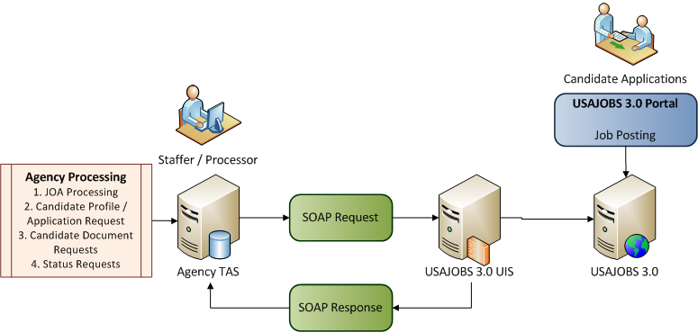
Figure 2-1: USAJOBS SOAP Processing
Each SOAP XML package will encapsulate several key components:
- Integration Partner Source Authentication. The USAJOBS XML leverages SOAP and it contains the USAJ Authenticate Token. The USAJ Authenticate Token is used to authenticate the sender as a valid integration partner. The establishment and maintenance of the Token will be managed by USAJOBS and is required for access to both the UAT (Test) and Production Environments. Different Tokens will be issued for Test versus Production Environments.
- If posting a position preview, the ValidatePreview XML node can also be provided as seen in screenshot below.
- HR-XML BOD. Following the Header information, the SOAP Body encapsulates the HR-XML BOD or specific data associated with the integration. For example:
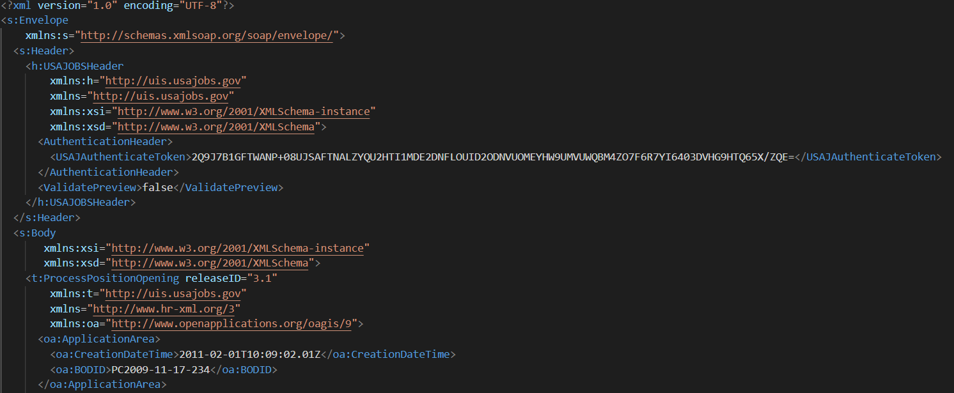

Processing Environments
USAJOBS will support two processing environments, Test and Production, which may be accessed via the SIF. Access to these environments will follow the same common security access protocol.
- Test Environment: UIS.UAT.USAJOBS.GOV
- Production Environment: UIS.USAJOBS.GOV

Integration Security
Integration Security and the protection of information are of the highest priority to OPM and all users of USAJOBS. The content of the USAJOBS SA&A package is maintained by the DSO and available for review by agency representatives. Any review must be scheduled with OPM and be conducted on the premises of OPM. Please contact the USAJOBS Program Management Office DSO to arrange a documentation review.
To support vendor partner integration, the following information is provided:
- Secure Connection. All integration communication will by HTTPS over SSLv3/TLS. The USAJOBS PMO and Operations teams will work with each integration partner to ensure the appropriate version is utilized.
- IP Address Validation. For each SOAP request generated from a TAS Vendor, the IP Address is validated against the USAJ Authenticate Token to verify the message as authenticate and being from an approved Vendor Partner. For communication to occur through the Staffing Integration Framework, the combination of IP Address and USAJ Authenticate Token must be valid.
- Communications Port. All HTTPS requests are published via Port 8443. This port provides a segregated security layer. Leveraging port 8443 enables an additional level of security as deployed in USAJOBS.
Once the authentication has been confirmed, the SOAP XML package will be processed by the UIS (USAJOBS Integration Server).

Web Services
The Staffing Integration Framework will leverage one web service, named “IntegrationServices”. The IntegrationServices Web Services Definition Language (WSDL) combines the HR-XML web services of ProcessPosition and Candidate into a single service for the USAJOBS initial deployment.
https://developer.usajobs.gov/docs/wsdl/integrationservices.wsdl
The IntegrationServices WSDL will leverage seven BODS to support the four Primary integration points:
- JOA Processing
  - ProcessPositionOpening BOD to Add and Change
  - CancelPositionOpening BOD to Cancel/Delete
  - AcknowledgePosition BOD to acknowledge Acceptance or Error.
- Candidate Profile/Resume
  - GetCandidate
  - ShowCandidate
- Document Management
  - GetCandidate
  - ShowCandidate
- Status Updates
  - ChangeCandidate
  - AcknowledgeCandidate

HTTPS Requests
Within USAJOBS the IntegrationServices Web Service will be instantiated over HTTPS. As the request varies in construct between each solution vendor’s technology deployment, a sample of both a .NET and JAVA based request are provided on Github. Access to samples is granted by request to Vendor Help (vendor-help@usajobs.gov).
As described in 2.1.4, each primary integration point (JOA Processing, Candidate Profile/Resume, Document Management and Status Update) utilizes specific BODs to support the associated business process. Each primary integration point has been defined in detail in Sections 3 through 7. On review of the XML provided for each integration point and supporting BODs, note the definition of all the attributes contained with the BOD, SOAP envelope and SOAP Header required to support the HTTPS Request.

USAJ Authenticate Token
The USAJ Authenticate Token is required for all TAS partners of USAJOBS. Each TAS integration partner must request approval to integrate with USAJOBS as noted below:
- Each USAJ Authenticate Token will be associated with a set of IP Addresses.
- A single USAJ Authenticate Token will be issued to each vendor for Test environment access. Based on the access granted, all approved vendors will have access to the entire testing environment without limitation to a specific organization (i.e., a vendor supporting multiple Federal agencies has access to the Test environment specific to the vendor as opposed to a token specific to each agency customer).
- Production Access. An Authenticate Token will be generated for each TAS Vendor with a set if IP Addresses. Vendors will have their USAJ Authenticate Token activated in Production once OPM has 1) confirmed the status of a FISMA-compliant SA&A resulting in an ATO for the interconnecting system; and 2) finalized an Interconnection Security Agreement (ISA) between the vendor organization and OPM.
The following steps are provided to assist agencies when requesting tokens and verify connectivity:
Step 1: Obtaining your SIF Token for UAT (Test Environment)
When vendor is ready to receive and start using the SIF token, the designated technical point of contact (POC) will send an email to Access@usajobs.gov. Within the email, we request:
- Title the email: SIF Integration Request – (insert Vendor Name)
- Attach the USAJOBS SIF UAT Registration Form. This form is available at schemas.usajobs.gov. The form will contain:
- Vendor Name
- Vendor Contact Info (Name, Email Address, Phone)
- The Vendors IP Address or Address range that USAJOBS should expect to receive SIF integration calls to and from.
- Are you working with a Federal Client (Yes or No)
- If you are working with a Federal Client, please identify the Agency and Primary Contact (Agency, Name, Email Address and Phone)
- If you are requesting access to SSO, SIF, or Both
- If you are requesting access to SSO, the URI that will be used to validate your access.
When the email request for Access is received, the USAJOBS PMO will verify the access request and approve access of the Test (UIS) environment. When approved, a Footprints account will also be established for the Vendor POC. Footprints is the system OPM uses to track Vendor requests, concerns and bugs. OPM will notify the POC of the access URL and access credentials for using Footprints. Please ensure interactions within Footprints use the SIF template.
Once Footprints access has been established, OPM will notify the agency POC of the SIF Token. This Token will be required for all SIF Interactions in the SIF and will allow the agency to access the Test (UIS) environment.
Step 2: Validating access to the UAT Environment
To validate access to the UAT Test Environment from the provided IP address(s), navigate to the following websites:
- https://uis.uat.usajobs.gov/IntegrationServices.svc?wsdl
- https://uat.usajobs.gov
Step 3: Validating the SIF Token
Agencies may validate the SIF token by performing the following actions:
- Download the sample JOA, ProcessPositionOpening-JOAAdd.xml from Github
- Replace the USAJAuthenticateToken with the token provided in Step 1.
- Utilize a tool such as Fiddler to post the job with the following information:
- POST: https://uis.uat.usajobs.gov/IntegrationServices.svc
- Request Headers
- SOAPACTION: http://uis.usajobs.gov/IProcessPositionOpening/ProcessPositionOpening
CONTENT-TYPE: text/xml
Request Body – contents of the sample xml document.

USAJOBS Functionality
Functionality needed to test UIS integration is available on https://uat.usajobs.gov.
Once you have successfully posted a job, you can view it at http://uat.usajobs.gov/GetJob/ViewDetails/xxxxxxxx (where xxxxxxxx is the DocumentId).

Error Messages
Within USAJOBS, significant work has been completed to provide greater clarity in errors messages returned. Error messages will be contained in the AcknowledgePosition, ShowCandidate and AcknowledgeCandidate BODs. All errors encountered with the transaction request will be identified in a single XML message sent back to the TAS. The following example is provided as an error response to a JOA posting.

<ResponseExpression actionCode=”Rejected”>Validation errors</ResponseExpression>
<ChangeStatus>
<Description>Please correct errors before resubmitting</Description>
<EffectiveDateTime>2/14/2011 3:05:40 PM</EffectiveDateTime>
<Reason>The SalaryBasisCode that you submitted, ‘PA – Per Annum’, is invalid.
For a complete list of valid codes, see http:// schemas.usajobs.gov/XSD/</Reason>
<Reason>The WhoMayApplyCode that you submitted, ‘371’, is invalid.
For a complete list of valid codes, see http:// schemas.usajobs.gov/XSD/</Reason>
<Reason>Location field 5142 is not a valid location.</Reason>
<Reason>Major duties field must exceed 300 characters</Reason>
<Reason>AcceptUploadResume field must be either ‘True’ or ‘False’.</Reason>
</ChangeStatus>

Host File Requirements
With USAJOBS, Host File changes are no longer required. USAJOBS now leverages separate URLs for Production and Test environments. Vendor systems now simply point to the correct environment for their users. This change significantly reduced challenges for users changing environments and simplified vendor integration to USAJOBS.

Schema Validation
The HR-XML standards were adopted to provide a vendor neutral, industry-standard integration deployment that is open, extendable and created specifically for HR integration. However, the USAJOBS implementation of HR-XML must allow for wide latitude of functionality and interpretation by the specific deployment using the standard. The SIF Guide is intended to document how USAJOBS implements the standard via the combination of the XSDs (XML Stylesheet Definitions) and the SIF Data Dictionary (defines the unique interpretations).
For example, user areas are a delivered mechanism within HR-XML to support the extension of standard data elements to include implementation unique data. OPM has initially deployed those elements and is working with HR-XML to gain adoption of Government-specific elements. When those additional elements are included in both the specification and the XSD, USAJOBS will leverage the new standard elements and enhance the level of support provided through the XSDs.
The published external XSDs currently do include the UserArea extensions for documentation and validation purposes. Although this is not in full compliance with HR-XML, it was done to ease migration to USAJOBS 3.0. For example, the Data Dictionary identifies those unique interpretations where the number of occurrences of an element or Unique Data differ from the HR-XML standard. The core XSDs will not be modified for the unique requirements to ensure future migration to updates in the HR-XML standard.
The following XSDs have been delivered for use by the TAS Vendors. The XSD fully documents the elements and associated enumeration values for all primary points of integration, with the exception of Large Reference Tables noted in Section 2.5 below. The URLs provided for validation are:

USAJOBS | https://developer.usajobs.gov/docs/xsd/sif_uis_usajobs.xsd
 | This schema contains the definitions for the USAJOBS header as well as references to the HR-XML BODs that are being utilized in SIF. It should be considered the primary XSD.
HR-XML | https://developer.usajobs.gov/docs/xsd/sif_hrxml.xsd
 | This schema contains the definitions for all elements specific to HR-XML.
OAGI / HR-XML | https://developer.usajobs.gov/docs/xsd/sif_oagis_9.xsd
 | This schema contains the definitions for all elements developed by OAGI being utilized within HR-XML.
OAGI / Previous | https://developer.usajobs.gov/docs/xsd/sif_oagis_datatypes.xsd
 | This schema contains the definitions for all data types developed by OAGI being utilized by the previous XSD.
Table 2-1: Schema Validation URLs
For additional definition on the SIF_OAGIS_9.xsd and SIF_OAGIS_DataTypes.xsd, the following URL provides documentation on the data standards leveraged by HR-XML, as developed by the OAG Consortium (Open Applications Group). Please note an HR-XML account is needed to access this information.
http://ns.hr-xml.org/schemas/org_hr-xml/3_1/Documentation/Guidelines/ch02.php#id546469

Reference Data
To facilitate consistent reference information for Reference Data a REST based API is available to pull reference data. The following APIs are available:

Area of Reference | URL
Academic Honors | https://data.usajobs.gov/api/codelist/AcademicHonors
Action Code | https://data.usajobs.gov/api/codelist/ActionCodes
Degree Type Code | https://data.usajobs.gov/api/codelist/DegreeTypeCodes
Document Format | https://data.usajobs.gov/api/codelist/DocumentFormats
Race | https://data.usajobs.gov/api/codelist/RaceCodes
Ethnicity | https://data.usajobs.gov/api/codelist/Ethnicities
Documentation | https://data.usajobs.gov/api/codelist/Documentations
Contact Supervisor Or HR | https://data.usajobs.gov/api/codelist/ContactSupervisorCodes
Credit System | https://data.usajobs.gov/api/codelist/CreditSystemCodes
Federal Employment Status | https://data.usajobs.gov/api/codelist/FederalEmploymentStatuses
Language Proficiency | https://data.usajobs.gov/api/codelist/LanguageProficiencies
Selective Service | https://data.usajobs.gov/api/codelist/SelectiveServices
Military Status Code | https://data.usajobs.gov/api/codelist/MilitaryStatusCodes
Referee Type code | https://data.usajobs.gov/api/codelist/RefereeTypeCodes
Special Hiring | https://data.usajobs.gov/api/codelist/SpecialHirings
Travel Percentage | https://data.usajobs.gov/api/codelist/TravelPercentages
Use Code | https://data.usajobs.gov/api/codelist/UseCodes
Position Offering Type | https://data.usajobs.gov/api/codelist/PositionOfferingTypes
Position Schedule Type | https://data.usajobs.gov/api/codelist/PositionScheduleTypes
Who May Apply | https://data.usajobs.gov/api/codelist/WhoMayApply
Hiring Path | https://data.usajobs.gov/api/codelist/HiringPaths
JOA Type | https://data.usajobs.gov/api/codelist/JoaTypes
Remuneration Rate Interval Code | https://data.usajobs.gov/api/codelist/RemunerationRateIntervalCodes
Application Status | https://data.usajobs.gov/api/codelist/ApplicationStatuses
Academic Level | https://data.usajobs.gov/api/codelist/AcademicLevels
Agency Role Code | https://data.usajobs.gov/api/codelist/AgencyRoleCode
Channel Code | https://data.usajobs.gov/api/codelist/ChannelCodes
Security Clearance | https://data.usajobs.gov/api/codelist/SecurityClearances
Key Standard Requirements | https://data.usajobs.gov/api/codelist/KeyStandardRequirements
Required Standard Documents | https://data.usajobs.gov/api/codelist/RequiredStandardDocuments
Disability | https://data.usajobs.gov/api/codelist/Disabilities
How Did You Hear About This Job | https://data.usajobs.gov/api/codelist/ApplicantSuppliers
Mission Critical Code | https://data.usajobs.gov/api/codelist/MissionCriticalCodes
Announcement Closing Type | https://data.usajobs.gov/api/codelist/AnnouncementClosingType
Service Type | https://data.usajobs.gov/api/codelist/ServiceType
Occupational Series Code | https://data.usajobs.gov/api/codelist/OccupationalSeries
Pay Plan Table | https://data.usajobs.gov/api/codelist/PayPlans
Country Code | https://data.usajobs.gov/api/codelist/Countries
Country Sub Division (Preferred Locations) | https://data.usajobs.gov/api/codelist/CountrySubdivisions
Location Codes – 9 Character Duty Station | https://data.usajobs.gov/api/codelist/GeoLocCodes
Zip Code | https://data.usajobs.gov/api/codelist/PostalCodes
Location Expansions | https://data.usajobs.gov/api/codelist/LocationExpansions
Agency Sub Element | https://data.usajobs.gov/api/codelist/AgencySubElements
Posting Channel ID and Agency Pages | https://data.usajobs.gov/api/codelist/PostingChannels
Vendor ID | https://data.usajobs.gov/api/codelist/VendorIDs
Language | https://data.usajobs.gov/api/codelist/LanguageCodes
Table 2-2 Large Reference File URLs
The API query parameters include:
Data Element | Description
LastModified | Specify either a date or a date time value. Locations that were added or modified after the specified date shall be returned.

The results return are in JSON format. XML format is available by using the following header when making the request to the API –
- Accept: Application/XML

Batch Processing via Secure FTP (SFTP)
The current deployment of USAJOBS does not support batch processing of SIF interactions. SFTP is only deployed to support Job Share functionality and is described in Section 7.

Single Sign-on for Applicants
Single Sign-On (SSO) is an important aspect of improving the candidate experience by making the transition of the candidate from USAJOBS to the integrated vendor solutions more seamless. USAJOBS now supports Single Sign-On with Release 4.0. Talent Acquisition System (TAS) Vendors may continue to integrate with USAJOBS using the current non-SSO implementation. However, TAS vendors will be required to implement integration with USAJOBS SSO by January 27, 2015.
Documentation for implementing the Single Sign-On integration is located in Github.

Technical Suggestions and Issues
If there are technical suggestions, please email the USAJOBS program management office at recruiter-help@usajobs.gov. If assistance is required or system challenges with the SIF environment need to be reported, please email vendor-help@usajobs.gov.

JOA (Job Opportunity Announcement) Processing Integration Specification
The JOA (Job Opportunity Announcement) Processing integration point is designed to receive Add and Change requests for JOAs via the ProcessPositionOpening BOD and Cancellation (Delete) requests via the CancelPositionOpening BOD. All requests for JOA Processing will be originated from the TAS vendor solutions. The only action automatically occurring for a JOA is the scheduled close of the JOA as defined by the Close date. It is expected the TAS will also simultaneously close the JOA within their system.
The content contained within the XML BODs will provide all data necessary to process the JOA request within USAJOBS. As part of the Web Service, a synchronous BOD will be generated back to the providing system acknowledging the JOA request and providing the status of the associated request (Accepted or Rejected).
It is important to note that the Web Service and corresponding BODs support the Add, Change, or Delete for a single JOA per request. Batch upload of multiple JOAs are not supported through this web service today.

Process JOA Add to USAJOBS
For a TAS to add a new JOA to USAJOBS, the following steps occur:
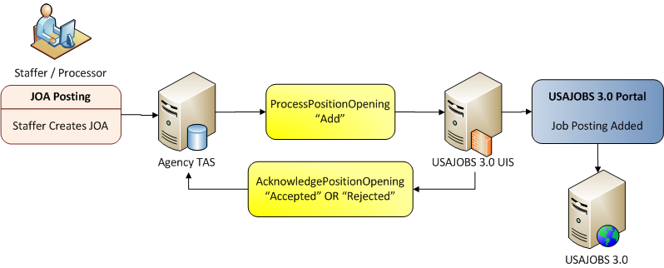
Figure 3-1: TAS adds a new JOA to USAJOBS
- The staffer will initiate a JOA in the TAS. When the JOA is ready to post to USAJOBS, the TAS will instantiate the IntegrationServices Web Service and generate the ProcessPositionOpening BOD. Within the BOD, the actionCode will equal “Add” and the BOD ID element should be populated with a unique identifier the TAS will use later to identify the specific JOA being acted upon.
- Upon receipt of the BOD from the TAS, USAJOBS UIS will validate the XML Schema, field validations (enumerations), and accept or reject (error) the BOD. If the JOA BOD is accepted, a DocumentID will be generated, containing the JOA Control Number. The accepted JOA will be posted to USAJOBS. If the JOA BOD is rejected, a specific error message will be generated with a detailed error response identifying the issues with the schema or data validation that occurred.
- The AcknowledgePositionOpening BOD will then be generated to the TAS. It will contain the BOD ID for referential integrity, include the generated DocumentID for the JOA Control Number and the status of Accepted or Error. If an Error is encountered, it will also include the Error Number and Error Message.
The following XML is required to support the JOA Add:
http://schemas.usajobs.gov/samples/ProcessPositionOpening-JOAAdd.xml

Process JOA Change to USAJOBS
For a TAS to change an existing JOA within USAJOBS, the noted steps below will occur. It should be noted that a “Change” is defined as a full replacement of the JOA content. All fields should be flowed USAJOBS, as the JOA content will be overlaid by the new content. USAJOBS does not support a Change Only model where only those fields being changed are provided. It should also be noted that to modify the Closing Date of a JOA (terminate earlier or extend), this is considered a Change action.
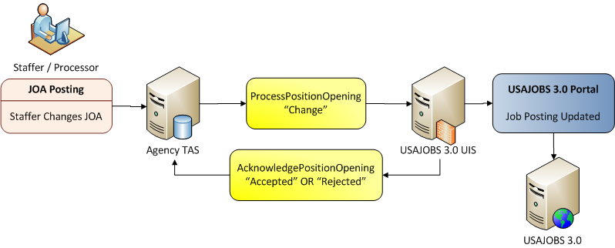
Figure 3-2: TAS submits JOA change to USAJOBS
- The staffer will initiate a change to the JOA in the TAS. When the JOA is ready to post to USAJOBS, the TAS will instantiate the IntegrationServices Web Service and generate the ProcessPositionOpening BOD. Within the BOD, the actionCode will equal “Change” and the BOD ID element should be populated with a unique identifier that the TAS will use later to identify the specific JOA being acted upon. It is also important to note that on a “Change”, the TAS must flow the previously provided DocumentID (JOA Control Number) with the appropriate value.
- Upon receipt of the BOD from the TAS, USAJOBS UIS will validate the XML Schema, field validations (enumerations) and accept or reject (error) the BOD. If the JOA BOD is accepted, the updated JOA will be posted to USAJOBS. If the JOA BOD is rejected, a specific error message will be generated with a detailed error response identifying the issues with the schema or data validation that occurred.
- The AcknowledgePositionOpening BOD will then be generated to the TAS. It will contain the BOD ID for referential integrity, the DocumentID for the JOA Control Number and the status of Accepted or Error. If an Error is encountered, it will also include the Error Number and Error Message.

Process JOA Cancel to USAJOBS
For a TAS to cancel an existing JOA in USAJOBS, the following steps will occur. It should be noted that a “Delete” will cause the immediate removal of the JOA from the Candidates view in USAJOBS. It is also important to note that Status Updates will be required for all Candidates that have applied to the cancelled JOA and it is expected that those updates will occur from the TAS once the cancel acknowledgement is received.
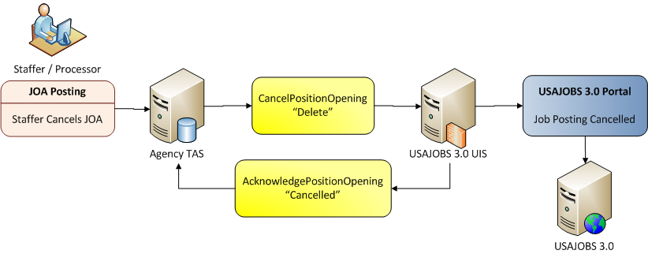
Figure 3-3: TAS submits JOA cancellation to USAJOBS
- The staffer will initiate a cancellation of the JOA in the TAS. When the JOA cancellation is ready to post to USAJOBS, the TAS will instantiate the IntegrationServices Web Service and generate the CancelPositionOpening BOD. Within the BOD, the actionCode will equal “Delete” and the BOD ID element should be populated with a unique identifier that the TAS will use later to identify the specific JOA being acted upon. It is also important to note that on a “Delete”, the TAS must flow the previously provided DocumentID (JOA Control Number) with the appropriate value.
- Upon receipt of the BOD from the TAS, USAJOBS UIS will validate the XML Schema, field validations (enumerations) and accept or reject (error) the BOD. If the JOA BOD is accepted, the updated JOA will be un-posted from USAJOBS. If the JOA BOD is rejected, a specific error message will be generated with a detailed error response identifying the issues with the schema or data validation that occurred.
- The AcknowledgePositionOpening BOD will then be generated to the TAS. It will contain the BOD ID for referential integrity, the DocumentID for the JOA Control Number and the status of Accepted or Error. If an Error is encountered, it will also include the Error Number and Error Message.

AcknowledgePositionOpening BOD.
The AcknowledgePositionOpening BOD will be generated synchronously with all requests to Add, Change or Delete a JOA. It will confirm if the request was accepted or rejected.

Request JOA Posting for Case File
To support Case File requirements, the ability to retrieve the actual USAJOBS JOA posting is required. A simple URL request has been provided that allows the Staffer, via the TAS, to initiate the request and have the JOA presented back to them. The URL would be:
- Production: http://www.usajobs.gov/GetJob/ViewDetails/329977
- Test: http://www.uat.usajobs.gov/GetJob/ViewDetails/329977
In the example noted above, the TAS is generating the request for JOA Control Number 329977.
This function can be requested at any point for a JOA, regardless if it is open or closed. The JOA will remain available for Case File access for three years from the Close Date, at which point it will be archived in accordance to Federal policy. Closed JOAs will be marked with additional text to indicate applications are no longer being accepted.

Return to USAJOBS Functionality
To support the “Return to USAJOBS” functionality, the user will be posted back to the Return URL sent at the Apply Online post time, once the application is complete. The agency/TAS will need to post back the value of the Application ID and optionally the Application Status value.

Apply Online Processing
The following JOA flags are used to control the behavior of the Apply Online process:
JOA Flag | Element | Behavior
Apply Online URL | GOVT_ApplyOnlineURL | If this is null, the Apply Online button will not display.
Disable Apply Online | GOVT_DisableApplyOnline | Set this to “true” if the JOA does not accept any resumes (including builder resumes) from USAJOBS.
Accept Uploaded Documents | GOVT_AcceptAttachedDocuments | Set this to “false” to not accept uploaded documents
Accept Uploaded Resumes | GOVT_AcceptUploadedResumes | Set this to “false” to not accept uploaded resumes
Table 3-1 JOA Flags and Associated Behavior
When a Seeker originates from a source outside of USAJOBS, the URL issued by the source (Job Board, Agency Career Site or Special Career Site) is changed. The URL will now contain the PostingChannelID associated to that source (e.g. 9999 in the example below) and it will contain the Return URL. The Return (Redirect) URL is used by USAJOBS to send the candidate back to the originating site once the application is completed. The Return URL is stored in USAJOBS with the application. The following example is provided:
https://my.usajobs.gov/Application/ApplyStart?id=11101100&PostingChannelID=9999&returnURL=returnURL

Key Changes to JOA Processing in USAJOBS

Locations
The JOA Processing can now handle an unlimited number of Locations. Locations can now be specified as GSA-GEOLOC or USPS Zip Codes.

Occupational Series
USAJOBS no longer limits the number of Occupational Series submitted with an individual JOA. OPM strongly encourages agencies to submit ten occupational series or less for a given vacancy.

Job Posting
The JOA will no longer be copied and published separately for each combination of grade, series and location. A single posting will be received and posted. When a candidate applies, they will apply to the JOA and associated JOA Control Number (DocumentID). It is the responsibility of the TAS to query applicants for the Grade(s), Location(s) and / or Series they wish to apply for. Additionally, this will simplify the number of IDs used to identify the JOA as the sub JOA Control Number reference IDs are no longer applicable.

PostingChannelID
As USAJOBS prepares to broaden its alternative sourcing capabilities, it is critical that the Job Posting Process enable the identification of alternative posting IDs. For the initial implementation, Posting Channel ID will be used to identify the Agency Search Pages that the JOA will also be presented in. This will allow for easier identification in the JOA for alternative posting and capture source data for future metrics. In future releases, Posting Channel ID will be expanded to include external posting capabilities.
USAJOBS will automatically insert the appropriate PostingChannelID(s) for corresponding Agency pages used for search. When a JOA is posted, the PostingChannelID will be interrogated. If it does not include the references for the agencies Search pages which match the search criteria, the corresponding reference will be inserted into the PostingChannelID.
For PostingChannelIDs which do not have Agency specific search references like HiringFair or RecoveryJobs, the TAS must include those PostingChannelIDs in the JOA Posting.

User Account Management
USAJOBS no longer requires the redundant maintenance of User IDs and Passwords. The JOA posting XML has been modified to include the TAS User attributes required to provide the necessary audit trail. The TAS will have full responsibility for the authentication of users and access to posting to USAJOBS. This change eliminates a burden of dual account maintenance and also will eliminate many challenges associated to posting JOAs directly impacted by the dual maintenance of Recruiter accounts.

Data Management
Each Agency is responsible for maintaining and collecting the content as defined in the USAJOBS JOA specification. With this specification, OPM is extending its existing process of accepting agency inputs through commercial and government Talent Acquisition System (TAS) vendors. OPM anticipates agencies will continue to submit JOAs though external providers. OPM will work individually with agencies that do not use external providers to identify alternative methods for data submission.

JOA Preview XSLT
Historically, staffers were required to post a job to USAJOBS to be able to preview how it would look on USAJOBS. In many cases, these were not actual jobs, but rather templates. As part of that process, staffers would future date the JOA to ensure that it did not appear on USAJOBS. Many times, these JOAs were to verify how specific text and embedded HTML would be presented within the JOA. To eliminate this requirement, USAJOBS is providing an XSLT that can be leveraged at the TAS level to provide a Job Preview function. The goal is to allow the XSLT to be leveraged locally within the TAS to support a preview function. That preview function would allow the staffer to see exactly how the job will appear within USAJOBS, without actually posting it to USAJOBS. Additionally, the local preview function will eliminate work for the Staffers, as once the JOA is previewed, the staffer will no longer to un-post or cancel the JOA later.
To leverage the XSLT, there are several items of note for the TAS vendor:

- SOAP headers should not be included. The root element needs to be ProcessPositionOpening with default namespace of “http://www.hr-xml.org/3”
- Formatting, styles and images are preconfigured.

The following URL links to the XSLT:
https://developer.usajobs.gov/docs/xslt/joatransform.xslt

Candidate Profile and Resume Integration Specification
The Candidate Profile and Resume (Application Specific Data) Integration is designed to notify the TAS whenever a new application is submitted or a candidate updates their application for an open JOA and wishes to have that information considered. Unlike the JOA integration, both add and change information will be flowed in the same BOD to the TAS. The TAS will discern if they need to interact again with the applicant to complete additional information required by the TAS.
For this integration point, USAJOBS will issue an HTTPS Form request (Post) to the TAS. This request will include a number of attributes to identify the key Candidate information and the JOA for which they are applying. The TAS will receive this request, determine if the candidate is already on file or if this is a new candidate application. The TAS will then request the Candidate’s Profile and Resume data through the IntegrationServices Web Service, using the GetCandidate BOD. When USAJOBS receives the GetCandidate BOD, it will synchronously generate the ShowCandidate BOD back to the TAS for insert or update by the TAS.
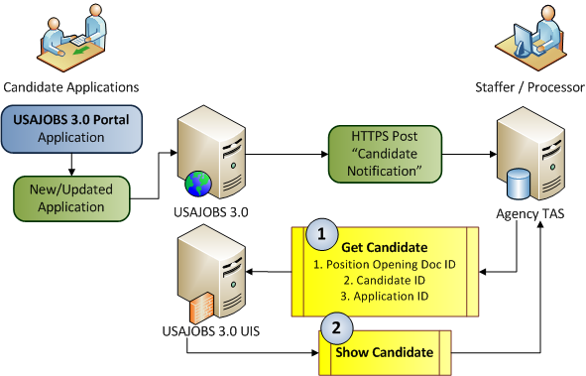
Figure 4-1: USAJOBS Get Candidate and Show Candidate process
If for any reason the GetCandidate BOD does not contain the correct request information to properly retrieve the Candidate profile and application, the Show Candidate will be returned with a Status of Fail and the appropriate error messages.
It is important to note that the Web Service and corresponding BODs supporting the Candidate Profile and Resume integration point sustain a single candidate per request. Batch request/receipt of candidates/applications are not supported through this web service today.

Candidate Application Notification
When a candidate completes or updates their application in USAJOBS, the TAS will be notified via an HTTPS Form post. The Form post will provide all variables required for the TAS to retrieve the Candidates profile and application data (resume data). It will also provide the information required to pull documents (Resume, Cover Letter, etc.) as well.
The Form Post Variables are:
Variable | Description | Comments
PositionOpeningID | PositionOpening.DocumentID in HR-XML or the JOA control number. | JOA Control Number
CandidateID | Candidate.DocumentID in HR-XML or the Candidate ID number | When using SSO, this id will not be in the form post but will pass as a claim in the SAML token.
ApplicationID | Candidate.AlternateDocumentID in HR-XML | Application ID
ReturnURL | ReturnURL | URL used to return Seeker to originating source upon completion of application processing.
DocumentInfo | DocumentInfo | DocumentInfo contains four attributes for each document, part of the application: Attachment ID, Attachment Type, Attachment Format Type, and Attachment Title.
SessionTicket | The SessionTicket is an application specific token. It is passed in the SessionID node in the GetCandidate BOD and is used to validate the seeker. | Although the use is optional, it is strongly encouraged that this value be used in GetCandidate calls.
SessionID | The SessionID is a SSO specific variable. This will match a claim in the SSO token. | This ID will not be in the form post unless SSO is turned on. The purpose of this variable is to more easily match the job seeker with the form post data after the user is redirected from the login site.
Table 4-1: HR-XML Form Attributes
USAJOBS, requires all attributes in Table 4-1 except SessionTicket. SessionTicket is also no longer required. It is provided in the Form Post, should the TAS desire to validate the session. Within all HR-XML provided in this document, the BODID is provided for each TAS vendor to generate a transaction specific identifier that links the request to the corresponding acknowledgement. Each TAS will control the value in BODID, based on their unique requirements to provide transactional integrity. USAJOBS will pass the vendor provided value from the request back in the acknowledgement for process and transaction continuity. An example of the HR-XML Form Post is located on Github.

Request Candidate Profile/Application
When the TAS receives the Candidate Application Notification (reference 4.1. above) from USAJOBS, it will need to store the contents of the form request for use later in integration dialogs with USAJOBS. Based on the information received in the Form request, the TAS will be able to determine if the candidate already exists and has an association with that particular JOA to determine processing needs. Processing could include an Add or Update Function in the TAS.
Upon receipt of the candidate application notification, the TAS will initiate the GetCandidate BOD via the IntegrationServices Web Service.
The supporting SOAP package is then issued for GetCandidate from the TAS. It will include the key identifying information to receive the candidate’s profile and application data (JOA Control Number, Candidate ID and Application ID).
As part of the HTTP Form post, the TAS may desire to validate the session. Validation of the session is optional. If the TAS does not wish to validate the session, simply do not include the Signature/SessionID node. Two options are provided to enable session validation.

Session Validation – Option 1
When the GetCandidate is issued to USAJOBS, the XML would contain the ApplicationArea/Signature/SessionID node with the SessionTicket value. When the GetCandidate BOD is received and processed, the SessionTicket will be validated automatically. If it is accepted, the ShowCandidate will be provided back to the TAS as Accepted and all Profile/Resume data will be included. If the SessionTicket fails, the ShowCandidate BOD will be returned with ResponseCriteria/ResponseExpression = “Fail”.

Session Validation – Option 2
When the GetCandidate BOD is issued, it will contain the ApplicationArea/Signature/SessionID node with the SessionTicket value and DataArea/Get/ Expression node with a value of GetCandidate/Candidate/Validate. When the GetCandidate BOD is received by USAJOBS, the SessionTicket will be validated and the ShowCandidate BOD will be returned with either Accepted or Fail as the Response Expression. The validate request does not return seeker data. The TAS would then issue a second GetCandidate with the normal DataArea/Get/Expression of GetCandidiate/Candidate and the Show Candidate would be returned with all seeker Profile and Resume Data.
It should be noted that the SessionTicket will be valid for 1 hour from the time of the HTTP Form Post.

Session Validation – Option 3

Receive Candidate Profile/Application at TAS
When the GetCandidate is received by the USAJOBS UIS, it will validate the request and return the ShowCandidate BOD synchronously to the TAS. The Show Candidate BOD will return a complete data set for the Candidate Profile and Application (Resume) with an actioncode of “Accepted” or a much smaller set of elements with an actioncode of “Fail”, with the corresponding error conditions described. Note: The GetCandidate requesting Session Validation (4.2 above) will not return seeker data.
The ShowCandidate XML will be presented in one of two formats, based on the seekers selection to use a Builder Resume (Structured Data) or attach a document resume. Example xml request and responses are available on Github.

Resume Preview XSLT
For TAS Vendors which need the Text Resume to support their processing requirements, OPM has developed an XSLT that transforms the ShowCandidate XML into a Text Resume. The following URL links to the XSLT:
https://developer.usajobs.gov/docs/xslt/PreviewResume.xslt

Key Changes to Candidate Profile and Application Processing in USAJOBS

SupplierPartyID
The SupplierPartyID was added to the Candidate Application to provide the foundation for tracking the source of the candidate. The use of this field will be expanded in later releases to document the source from which a candidate applied beyond USAJOBS or a USAJOBS A9 Page.

Basic Eligibility Questions
Several questions were added to the Candidate Profile experience to request core information once and flow the information to the TAS providers, thus eliminating redundant data capture. The new Eligibility questions that flow responses are:
- US Citizenship
- Selective Service
- US Veteran
- Federal Employment Status

Data Management
Each Agency is responsible for maintaining and collecting the content as defined in the USAJOBS Candidate Profile and Application specification. With this specification, OPM is extending its existing process of accepting agency integration with commercial and government TAS vendors.

Document Management Integration Specification
The Document Management Integration is designed to leverage the Candidate Application Notification defined in 4.1.1 above. When the TAS is notified of a new application submission or a candidate updates their application, the Document control information will be provided with the HTTP Form Post. The Form Post identifies all documents which apply to the candidate’s application in the DocumentInfo attribute.
The TAS will determine when specific or all documents are requested from USAJOBS. A key component of this integration supports the ability of the TAS to request the appropriate documents as it applies to the workflow associated with a particular JOA. For example, the TAS could request the resume for all applicants, but wait to request other documents until an applicant met minimum qualifications. Alternatively, the TAS could request all documents as part of a common process.
When USAJOBS issues the Candidate Notification Request (see 4.1.1), the HTTPS Form Post to the TAS will include an attribute called DocumentInfo. DocumentInfo provides four sub-element pieces of information for each document considered part of the candidate’s application. The four sub-elements will occur for each and every document in the DocumentInfo attribute. The Sub-Elements are:
- AttachmentID. Unique Identifier of the Document systematically generated. AttachmentID will be used to populate the document request to USAJOBS to retrieve the document by the TAS.
- AttachmentType. The Type of Document is used to group like kinds of documents together. The enumeration table defines all valid values (e.g. Cover Letter, Resume, etc.)
- AttachmentFormatType. The format type defines which technology format the document is stored in. Valid format types are: Microsoft Word (.Doc and .Docx), pdf, jpg, GIF, jpeg, png, and rtf.
- AttachmentTitle. The title of the document is provided for reference.
As part of receiving the Candidate Notification Request the TAS will need to store the DocumentInfo for later use in requesting the documents. The GetCandidate BOD is used by the TAS to request each document. Following the completion of the application in the TAS, the TAS will request each document through a separate Web Service call leveraging the GetCandidate BOD.
When USAJOBS receives the GetCandidate BOD, it will synchronously generate the ShowCandidate BOD back to the TAS with the requested document.
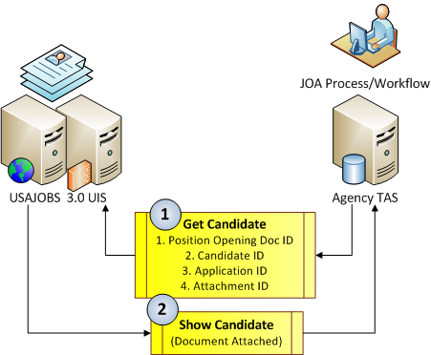
Figure 5-1: USAJOBS document exchange
If for any reason the GetCandidate BOD does not contain the correct request information to properly retrieve the document, the Show Candidate BOD will be returned with a Status of Rejected and the appropriate error messages.
It is important to note that the Web Service and corresponding BODs supporting the Document Management integration point sustain a single document per request. Batch request/receipt of documents is not supported through this web service.

Request Application Document
The TAS will initiate the GetCandidate BOD via the IntegrationServices Web Service.
The supporting SOAP package is then issued for GetCandidate from the TAS. It will include the key identifying information to receive the candidate’s profile and application data (JOA Control Number, Candidate ID, Application ID and Attachment ID. The Attachment ID will reflect the unique ID for the document requested.

Receive Application Document at TAS
When the GetCandidate is received by the USAJOBS UIS, it will validate the request and return the ShowCandidate BOD synchronously to the TAS. The Show Candidate BOD will return the document with an actioncode of “Accepted” or an actioncode of “Rejected”, with the corresponding error conditions described.

Virus Check
All documents attempting to upload into USAJOBS will have a Virus Check performed before storage. Although the Virus Check function is not part of the SIF, it is important to note the User Interface will ensure all documents provided to the TAS or other solution providers have undergone virus scanning.

Data Management
Each Agency is responsible for maintaining and collecting the content as defined in the USAJOBS Document Management specification. With this specification, OPM is extending its existing process of accepting agency integration with commercial and government TAS vendors.

Status Update Integration Specification
The Status Update Integration is designed to allow the TAS to report changes:
- For a single status change; and/or
- For a single candidate with multiple status changes; and/or
- For multiple candidates with a status change; and/or
- For multiple candidates with multiple status changes.
The reported status changes will be processed in the order in which they are provided within the XML document. This design provides flexibility to the TAS systems to report changes dynamically as those changes occur and/or in batches.
To report Status Changes (previously known a Round IDs), the TAS will initiate the ChangeCandidate BOD. The ChangeCandidate BOD will encapsulate the status changes for each candidate and their associated application through a single Web Service.
When USAJOBS receives the ChangeCandidate BOD, it will validate each change request and synchronously generate the AcknowledgeCandidate BOD back to the TAS. Within the AcknowledgeCandidate BOD, each status change will be either Accepted for Rejected with the requested document.
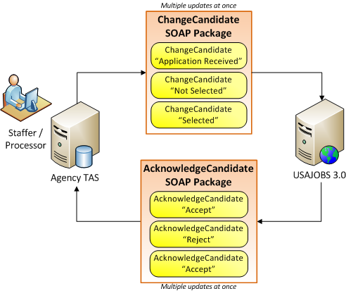
Figure 6-1: USAJOBS Status Update process
It is important to note that the Web Service and corresponding BODs supporting the Status Update integration point sustain multiple updates per request.

Request Status Updates
The TAS will initiate the ChangeCandidate BOD via the IntegrationServices Web Service. The supporting SOAP package is issued for ChangeCandidate from the TAS. It will include the key identifying information to update each candidate’s application status contained within the package. As multiple updates can be submitted, each update will recur.

Receive Status Update Processing Status at TAS
When the ChangeCandidate is received by the USAJOBS UIS, it will validate the request and return the AcknowledgeCandidate BOD synchronously to the TAS. The AcknowledgeCandidate BOD will return an actioncode of “Accepted” or Rejected for each status update contained within the package. If an actioncode of “Rejected” is received for a status update, with the corresponding error conditions is provided and described.
The following file presents the AcknowledgeCandidate SOAP Package. It includes an example for both an “Accepted” status update and a “Rejected” Status update. Please note that following the Acceptance or Rejection is the Application ID associated with the Status Change.

Data Management
Each Agency is responsible for maintaining and collecting the content as defined in the USAJOBS Status Update specification. With this specification, OPM is extending its existing process of accepting agency integration with commercial and government TAS vendors.

Job Sharing
To increase visibility to the general public, USAJOBS supports many consumers of JOA data. USAJOBS provides the ability to share JOA content in three primary methods, based on the type of Consumer. A Consumer is any seeker, agency or specialized government site who wishes to have content exported or visualized from USAJOBS to support broader visibility of Job Opportunities. As OPM evaluated the best practices for distributing JOA content from USAJOBS, it desired to streamline and standardize the way in which the information was shared. The new approach broadens the amount of data available, standardizes the flow of the information, and formally documents the data export Consumers. Under this specification, Consumers will now use:
- JOA Export. JOA Export to consume JOA content to their agency or specialized government sites,
- Job Search. Agencies will have the opportunity to dynamically link to USAJOBS search in three different methods to support presentation of JOAs without requiring them to physically consume a JOA export.
  - Branded Agency Page.
  - Agency Search Page.
  - Utilizing search urls

JOA Export to Agencies and Specialized Government Job Boards.
The JOA export is designed to provide JOAs via a nightly batch export of JOAs applicable for each Consumer. The Consumer of the JOA Export will typically be the Agency who will leverage the content for their agency site or a specialized government job site. The export assumes that the Agency Site has an existing user interface and search engine that will render the JOA content to the seeker.
In this approach, OPM will identify each Consumer within the USAJOBS environment as a JOA consumption partner. This is different than a vendor. A vendor is typically identified as a TAS that provides and receives transactional content beyond a JOA. A Consumer will only receive content from USAJOBS and will direct candidates who wish to apply for jobs to the USAJOBS site via the Apply Online URL.
The JOA Export uses a data-driven design to document each export requirement within the system. The definition of the Consumer will include specific information about the Consumer and also their query requirements. The query requirements will be supported by the USAJOBS Search Engine and will filter all JOA postings (Add, Changes and Deletes) to control the breadth and depth of JOAs exported to them.
On a nightly basis (after 12:00 PM EST), the batch export will run, exporting all JOA activity for the prior day, based on the query requirements. The output file will then be published to a secure SFTP (Secure File Transfer Protocol) server and each Consumer will download their file from the SFTP server for import into their solution. It is important to note that each Consumer must enter into an agreement with the USAJOBS Program Office and clearly outline their export requirements. Those Consumers wishing to deploy JOA Export, should follow the instructions in 7.1.1 below to request an export.
Upon completion of the batch export process, a second batch process will run to clean up the SFTP server. The Cleanup process will delete all files older than 10 days old. This approach allows support of the export, while limiting the storage impacts associated with it.
A single integration will be used for each JOA Consumer. To provide the greatest flexibility, the core search engine will be leveraged to define a saved search that represents the query results required by a JOA Consumer. The intent is to provide a single query, per consumer, that selects all appropriate JOA content (adds, changes and deletes) for each day. The export program will execute each Consumer’s saved search and then export the associated JOA content to an export file represented in XML.

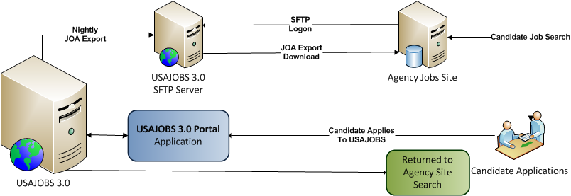
The following file presents the ShowPositionOpening XML that will be exported to each consumer. Sample ShowPositionOpening XML available on Github.

JOA Export Access and Tracking
The Consumer ID table will be used to identify and define each consumer of the JOA Export. One export will be allowed per consumer (Agency or Department). The table will document each Consumer and will be managed by the PMO via the USAJOBS System Administrator’s console for maintenance of information. When a Consumer wishes to be added to the JOA Export process, the organization will need to provide the information defined in the USAJOBS JOA Export Registration Form and agree to the USAJOBS JOA Export Terms of Service. Both documents are located at http://schemas.usajobs.gov/. An email should be submitted to Access@usajobs.gov with the information noted in the form and with an email subject line of: “JOA Export Request (Vendor Name/Agency Name)”. Please note the Agency contact info is required to identify the vendor is working on behalf of the agency at the technology/platform level of their solution.
Once the Access Request has been received, the USAJOBS Program Office will review for approval. Upon approval, a Footprints UserID and password will be established for the Consumer. The Consumer will be notified of their approval, approved access credentials, and URL.
Simultaneously, SFTP access will be configured for the Consumer. The technical POC will receive detailed information including the:
- SFTP server name
- Approved Access Credentials (UserID/Password OR Public key authentication using a public and private key pair)
- Authentication Credential expiration details
- Job Share file name
- Instructions regarding testing connectivity and retrieving the JOA Export file
Once the SFTP configuration is completed, the JOA export for that Consumer will be configured to reflect the Search requirements. Initial access will be granted to the Consumer in the test environment. This will allow the consumer to begin testing the export.
To gain access to production information, an agreement will be completed between the USAJOBS Program Office and the consumer. Once the agreement is completed and executed production access will be enabled.

JOA Export
The JOA Export will include both the Code and Description of each code for any element that is code based. OPM designed the JOA export to help consumers avoid maintaining a separate version of the enumeration tables. It is the decision of the Consumer as to what information they will present and how, within the limits of the Terms of Service.
For elements which provide an override description capability, like location, the override description will be flowed in lieu of the actual code description when it is provided.
When JOAs are exported, they may contain embedded HTML to highlight specific attributes or information within the JOA. The JOA is exported, as provided by the agency, and will include all embedded HTML. We cannot strip the embedded HTML from the JOA text fields.
The JOA Export includes all current and future dated JOAs which have been posted. Both are included in the export as the design is to support the Add, Change and Delete functionality. It is the responsibility of the consumer to filter the JOAs presented through their site.
The element GOVT_ApplyOnlineURL will be predefined for all exported JOAs and contains the URL that takes the Applicant to the exact page in the USAJOBS to present that JOA they are requesting to apply too. For example:
https://www.usajobs.gov/Application/ApplyStart/322908800

Sourcing and Redirect to Origination
The consumer now has two ways in which to direct the candidate to USAJOBS. They can redirect the candidate to USAJOBS via the ApplyStart URL noted in 7.1.2 or they can redirect the candidate using the GetJob/ViewDetails url as defined below. Leveraging the “id” noted in the provided GOVT-ApplyOnlineURL, the consumer will construct the appropriate URL.
When the consumer constructs the URL, they will append two critical pieces of information. The URL will contain the PostingChannelID associated to that consumer site and it will contain the returnURL used by USAJOBS to send the candidate back to the consumer’s site once the application is completed.
It should be noted that the returnURL must contain the PostChannelID prime URL. The prime URL will have been validated for security purposes and is stored with the PostingChannelID. For example:
PostChannelID VaforVets
PostChannelID prime URL: http://vaforvets.gov
The returnURL submitted is http://vaforvets.gov/jobsearch/jobid=1139902. As you see the returnURL provided begins with the prime URL.

Option 1. The following example is provided for ApplyStart:
https://www.usajobs.gov/Application/ApplyStart/322908800?PostingChannelID=VAVets&ReturnURL=returnURL
When the application is completed, the applicant will be sent back to the consumer site to the specific location they were at (search view) at the time they were redirected to USAJOBS via the returnURL
Option 2. The following example is provided for GetJob/ViewDetails:
In this scenario, the consumer would direct the candidate to USAJOBS to review more detailed information about the JOA. USAJOBS will keep the PostChannelID and returnURL in memory for that candidates session. If they apply, USAJOBS will associate both elements to the application. When the application is completed, the candidate will then be returned to the returnURL of the consumer.
https://www.usajobs.gov/GetJob/ViewDetails/xxxxxxx?PostingChannelID=VAforVets&returnURL=http://vaforvets.gov/jobsearch/jobid=12343389

JOA Export Search Criteria
The following Search Attributes will be available to filter the JOA Export for each consumer. Operationally, the search query will always be built to exclude Exclusive Postings. Internal JOAs will be determined based on the Consumer query/results requirements.
- Agency
- Agency Sub Element
- Title
- Series
- Salary Low
- Salary High
- Grade Low
- Grade High
- Location
- Applicant Eligibility (Who May Apply)
- SES Only Posting (Yes/No)
- Postings Older than 30 Days (Yes/No)
- Type of Work
- Work Schedule
- PostChannelID
The Saved search will be defined to select all records with Creation/Change date of prior day (Current Date – 1 Day) and/or Expire Date of Current Date. When a JOA has a close date of the prior day, the Expire date will be set to the following day. All JOAs which should be closed will be expired after 12:01 on the following date, prior to the JOA export occurring. For example: If the JOA Close Date was 10/1/11, the JOA Expire Date would be set to 10/2/11. For the extract created on 10/2/11, all adds and changes to JOAs processed for 10/1 will be exported and all cancellations/expirations with 10/2/11 will also be selected.

JOA Export Access Requirements
Daily export files are accessed using an OPM-provided UserID and Password or a Public/Private key authentication process. Either option allows Consumers to access the SFTP server. The SFTP encrypts both the commands and data, preventing access credentials and sensitive information from being transmitted in the clear. Many FTP clients support SFTP. Retrieving data will be over the default SFTP/SSH port, 22. It is the organization’s responsibility to choose the appropriate SFTP software for its application and environment. Agencies will also need to ensure firewall administrators allow traffic in and out of port 22 from their agency’s server to the Job Share SFTP server.
The JOA export file will be exported to either a Prod or Test directory. OPM has designed the structures to ensure while Production (Prod) exports are being leveraged new changes for an upcoming release can be simultaneously received for testing an upcoming release (Test).
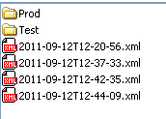
Additionally, OPM has placed a History folder within Prod and Test to allow the consumer to move files exported to History upon completion. The movement of the files to History is optional and is provided for convenience of the consumer.
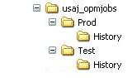

Job Search
Job Search provides real-time presentation of Job Opportunity Announcements (JOAs) to seekers. It allows the agency site to link Job Seekers directly to USAJOBS without replicating the JOA content into an agency specific environment. As OPM has worked with different agencies, it identified three specific approaches required to meet the agency requirements.
- Branded Agency Page. The Branded Agency Page presents JOAs to seekers with a specific agencies logo or banner meeting pre-defined search criteria.
- Agency Search Page. The Agency Search Page presents the JOAs to seekers only in the standard search view, based on pre-defined search criteria.
- Dynamic Search Query Service. Dynamic Search presents the JOAs to seekers in the standard search view, but allows the agency to submit filter attributes to select specific types of jobs that are relevant.
Regardless of which option that is chosen for use, the standard search view for JOAs is presented to the Seeker in a pop-up window. As the agency links to USAJOBS from their specific site, a new window will open presenting the search results. The seeker can view the JOAs, review the details of specific JOAs and apply for those jobs without leaving the search view. When they are finished, they return to the agency site by simply closing the USAJOBS window.

Branded Agency Page
A Branded Agency Page option is provided for those agencies who wish to link to USAJOBS JOA Search directly from their agency Careers Section. This view allows the agency to have the JOA search presented with their Logo or Banner and it will be presented as a separate window via pop-up. This approach allows the seeker to navigate between the USAJOBS search view and the agency page. Additionally, when the seeker is presented the search view, they can review all jobs within the search view, drill down to the specifics of those jobs and apply directly within USAJOBS without having to move between systems. OPM has pre-configured the search query so a consistent view of information is always presented.
One of the values of establishing a specific Branded agency page is that OPM will establish a Posting Channel ID with that page. The establishment of this ID allows us to differentiate where the seeker originated their job search. In the future OPM will be creating “Sourcing” reports that allow us to specifically identify which sources seekers come from for an Agency or Sub Agency. This information will help the agency better understand which sources are most commonly used by Seekers. The Post Channel ID will be automatically updated to the Seeker Application data when they originate from a Branded Agency Page.
As part of establishing a Branded Agency Page, agencies will need to provide either a logo or banner image file. The logo should be no larger than 130 X 130 pixels. If the agency chooses to provide a banner instead of a logo, it should be no larger than 700 X 130 pixels. The banner or logo should be provided as either a JPEG or PNG format with a resolution high enough for web use. The size of the banner/logo has a direct impact on the presentation of the search page. In addition to the Banner/Logo, OPM will need the recruiting/marketing statement agencies want displayed on the page. This statement should be no longer than 300 words.
When the page is created, OPM will provide a standard and simple URL to access the branded Agency Page configured with the logo/banner and marketing statement. The URL is always: Organization.usajobs.gov. In this example, replace organization with the acronym or name of your organization. As example, AirForce.usajobs.gov or CDC.usajobs.gov.
To have a branded Agency Page established for your agency, organizations should submit an email request to recruiter-help@usajobs.gov. Provide the following information in the content of the email:
- Name, Email Address and Phone of the agency POC
- Agency recruiting/marketing statement (300 words or less)
- Desired URL
- Logo or banner image file
Additionally agencies should identify the search criteria to associate with the page.
Data Element | Description
Agency(s) | Required – Example AF for all Air Force
Agency Sub Element(s) | Optional – Example HE39 for CDC
Title(s) | Optional – Specific Title Search Only
Series(s) | Optional – 0602 would select only doctors
Salary Low | Optional
Salary High | Optional
Grade Low and High | Optional
Location(s) | Optional
Applicant Eligibility | Required – External (Includes Internal Posted to USAJOBS) or SES Only
Results Filter Setting | Optional – Should the results default to Jobs for US Citizens or Jobs for Federal Employees? Default is Citizens.
SES Posting | Optional – Yes/No – Default is No
Postings Older than 30 Days | Optional – Yes/No – Default is No
Type of Work | Optional
Work Schedule | Optional
PostChannelID | Optional
Table 7-1 Agency Page Search Criteria

Agency Search Page
An Agency Search Page option is provided for those agencies who wish to link to USAJOBS JOA Search directly from their agency Careers Section, but do not wish to have the search view branded. This option works identically to 7.3.1 above without the branding.
To have an Agency Search Page established for your agency, you should submit an email request to recruiter-help@usajobs.gov. Provide the following information in the content of the email:
- Name, Email Address and Phone of the agency POC
- Desired URL
Additionally agencies should identify the search criteria to associate with the page.
Data Element | Description
Agency(s) | Required – Example AF for all Air Force
Agency Sub Element(s) | Optional – Example HE39 for CDC
Title(s) | Optional – Specific Title Search Only
Series(s) | Optional – 0602 would select only doctors
Salary Low | Optional
Salary High | Optional
Grade Low and High | Optional
Location(s) | Optional
Applicant Eligibility | Required – External (Includes Internal Posted to USAJOBS) or SES Only
SES Posting | Optional – Yes/No – Default is No
Postings Older than 30 Days | Optional – Yes/No – Default is No
Type of Work | Optional
Work Schedule | Optional
PostChannelID | Optional
Table 7-2 Agency Search Page Search Criteria

Data Dictionary Specification

Overview
The USAJOBS data elements are described in the embedded Data Dictionary spreadsheet. Because of the large number of columns, the spreadsheet has been designed to group multiple columns into areas of interest. By taking this approach, the user can view the data more easily based on what information is of interest. The Data Dictionary uses the standard grouping convention above the column names with a + (indicates the group is collapsed) or – (indicates the group is expanded). Additionally, each column provides for filtering to provide additional focus of the information. For example, if you only wanted to see data elements which pertain to the ProcessPositionOpening BOD (JOA Add or Change), you would go to the SIF Guide group, click on the + and then filter the ProcessPositionOpening column for Yes. The outcome is that all data elements which apply to that BOD would be presented.
The following columns and groupings are provided:
Column | Group | Description
DD # |  | Unique, sequential number assigned to each retirement data element in the USAJOBS Data Dictionary for identification purposes. Number assigned to a data element may change between versions.
Data Element Name |  | Name of the USAJOBS data element.
Data Element Description |  | Description of the USAJOBS data element.
USAJOBS 3.0 Schema Name |  | Element name in the HR-XML schema
HR-XML Path | Data Definition | Location of the element in the USAJOBS schema (as built using HR-XML)
Data Type | Data Definition | The data element format type and length. See Section 7.4 for details
Phase | Data Definition | Identifies the implementation phase associated with the data element. Most elements are defined as 1. Those elements defined as 2 are targeted for Phase 2 and exist in the XML, but are commented out. Items with Sys, are elements used in USAJOBS that do not affect the SIF. Those identified with TBD are planned, but not assigned to a formal release.
Repeating Field | Data Definition | Identifies if the data element recurs either independently or if it recurs within a group (e.g. employment history)
Required | Data Definition | Identified is the field is required (Yes), not required (No) or is conditionally required (COND). If the element is conditionally required, see the business logic column to understand the dependencies.
Valid Values | Data Validation | Defines if the element is validated against an enumeration table. The value will be the actual enumeration table used (If CodeList, the Element name controls the valid values). N signifies no validation. Yes-Code will identify validation based on rules contained in Business Logic and true/false indicates true or false.
Business Logic | Data Validation | Defines any business logic associated with the data element.
Source | Data Validation | Defines the originating source of the data.
Process Position Opening | SIF Schema | Used to Identify and Filter data element rows which apply to this particular BOD. All columns with Yes indicate the element is used in that BOD.
Cancel Position Opening | SIF Schema | Used to Identify and Filter data element rows which apply to this particular BOD. All columns with Yes indicate the element is used in that BOD.
Acknowledge Position Opening | SIF Schema | Used to Identify and Filter data element rows which apply to this particular BOD. All columns with Yes indicate the element is used in that BOD.
Get Candidate | SIF Schema | Used to Identify and Filter data element rows which apply to this particular BOD. All columns with Yes indicate the element is used in that BOD.
Show Candidate Resume/Profile | SIF Schema | Used to Identify and Filter data element rows which apply to this particular BOD. All columns with Yes indicate the element is used in that BOD.
Show Candidate Document | SIF Schema | Used to Identify and Filter data element rows which apply to this particular BOD. All columns with Yes indicate the element is used in that BOD.
Change Candidate | SIF Schema | Used to Identify and Filter data element rows which apply to this particular BOD. All columns with Yes indicate the element is used in that BOD.
Acknowledge Candidate | SIF Schema | Used to Identify and Filter data element rows which apply to this particular BOD. All columns with Yes indicate the element is used in that BOD.

USAJOBS Data Dictionary
To view all recruitment and staffing data elements identified by OPM as of the publication of this Guide, see the Data Dictionary published on the USAJOBS Github Schemas repository. The USAJOBS Data Dictionary is a working document and will continue to be revised. As a result, data providers should make system updates based on the latest version of the SIF Guide and associated the Data Dictionary.

Data Element Format Types
This table describes data types appearing in the Data Dictionary for each element.
Format | Description
TEXT_F(n) | Text field with fixed length of n characters. This format can consist of letters only, a combination of letters and numbers, and/or any special character EXCEPT the vertical line (pipe character “|”).
TEXT_V(n) | Text field with variable length up to n characters. This format can consist of letters only, a combination of letters and numbers, and/or any special character EXCEPT the vertical line (pipe character “|”).
NUMBER_F(n) | Numeric field with fixed length of n digits with no decimal.
NUMBER_V(n) | Numeric field with variable length up to n digits with no decimal.
DECIMAL(n,m) | Numeric field with variable length up to n digits with up to m digits to the right of the decimal.
DATE | A date consisting of a 4 character year, followed a 2 character numeric month (01-12), and a 2 character numeric day (01-31), separated by dashes (e.g. 2004-12-31).
Table 8-1: Data Dictionary data types

Job Opening Announcement (JOA) Data Specification
To view the data elements defined as part of the JOA processing requirements noted in Section 3, simply filter the data dictionary. Go to the SIF Schema group and expand it (click on +). For the BOD of interest, click the filter button for the BOD and select Yes. The outcome will be a listing of all the data elements which apply to that BOD. Note, once your organization is finished working on the BOD, don’t forget to go back to the filter and Select All. Filters will stay in effect until changed. See the example below.
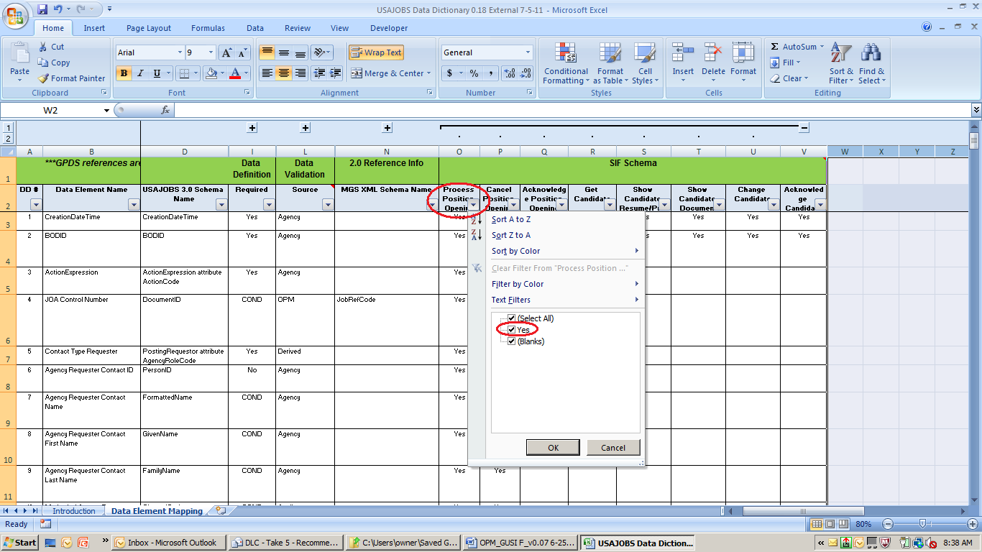
Figure 8-1: Data Dictionary filter example
The BODs which apply to JOA processing are:
- Process Position Opening
- Cancel Position Opening
- Acknowledge Position Opening

Candidate Profile and Resume Data Specification
To view the data elements defined as part of the Candidate Profile and Resume processing requirements noted in Section 4, simply filter the data dictionary. Go to the SIF Schema group and expand it (click on +). For the BOD of interest, click the filter button for the BOD and select Yes. The outcome will be a listing of all the data elements which apply to that BOD. Note, once your organization is finished working on the BOD, don’t forget to go back to the filter and Select All. Filters will stay in effect until changed. Filters will stay in effect until changed. See the example below.
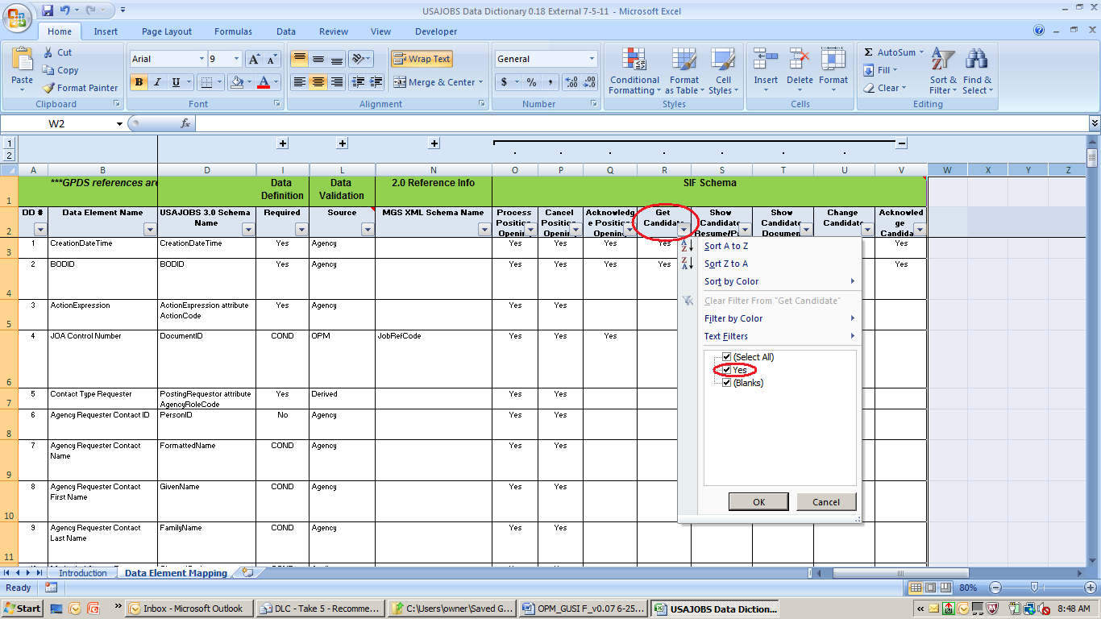
Figure 8-2: Data Dictionary filter example
The BODs which apply to JOA processing are:
- Get Candidate
- Show Candidate Resume Profile

Document Management Data Specification
One of the most critical components of Federal Hiring Reform is allowing applicants the ability to apply for jobs using an uploaded resume. Additionally, all other documents required for the application process will be gathered, stored and ultimately flowed to the TAS. If a user doesn’t have a resume to upload he or she can use the USAJOBS resume builder to create a resume within the site.
To view the data elements defined as part of the Document Management processing requirements noted in Section 5, simply filter the data dictionary. Go to the SIF Schema group and expand it (click on +). For the BOD of interest, click the filter button for the BOD and select Yes. The outcome will be a listing of all the data elements which apply to that BOD. Note, once your organization is finished working on the BOD, don’t forget to go back to the filter and Select All. Filters will stay in effect until changed. See the example below.

Figure 8-3: Data Dictionary filter example
The BODs which apply to JOA processing are:
- Get Candidate
- Show Candidate Document

Status Update Data Specification
To view the data elements defined as part of the Status Update processing requirements noted in Section 6, simply filter the data dictionary. Go to the SIF Schema group and expand it (click on +). For the BOD of interest, click the filter button for the BOD and select Yes. The outcome will be a listing of all the data elements which apply to that BOD. Note, once your organization is finished working on the BOD, don’t forget to go back to the filter and Select All. Filters will stay in effect until changed. See the example below.
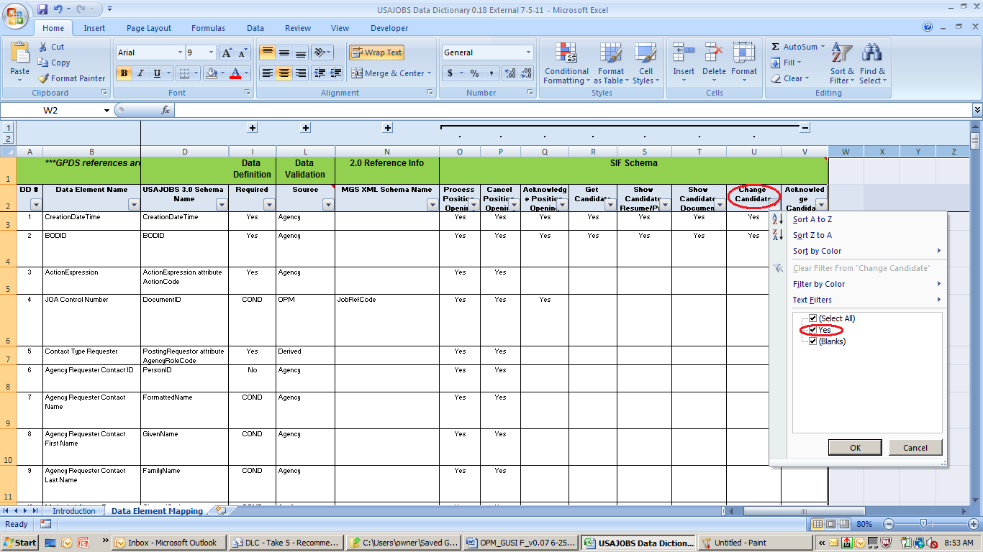
Figure 8-4: Data Dictionary filter example
The BODs which apply to JOA processing are:
- Change Candidate
- Acknowledge Candidate

Data Dictionary Valid Values
All data validations are identified in the Data Dictionary under column Valid Value (Data Validation Group). Multiple enumeration tables are used and are defined in section 2.5 of this document.
Standard enumerations (valid values) not “effective dated” are managed within the CodeList enumeration table. Within this table, the codes and descriptions are identified by the USAJOBS 3.0 Schema Name. For large reference tables – location, occupational series, etc. – their information is contained in a unique table for each large reference table. These tables also include a flag for IsDisabledOn and Effective date. The values in these tables typically change over time and the values will be effective dated when they go into effect or effective dated with the code is not longer valid (IsDisableOn equal to Yes).
Within the Valid Value column, the value will be the actual enumeration table used (If CodeList, the Element name controls the valid values). No validation is noted with an “N”. Yes-Code will identify validation based on rules contained in Business Logic and true/false indicates true or false.
Where possible, OPM is moving data elements to leverage the government wide GDS (Guide to Data Standards) standard codes. Some data elements were not changed for the initial phase of USAJOBS 3.0 simply based on the impact to the vendors and agencies in migrating to USAJOBS. Where impact was minimal, those data elements have been transformed to the data standard.
The Guide to Personnel Data Standards (GPDS) can be found using the following link: http://www.opm.gov/feddata/guidance.asp.

